**Posted on 1/23/18**

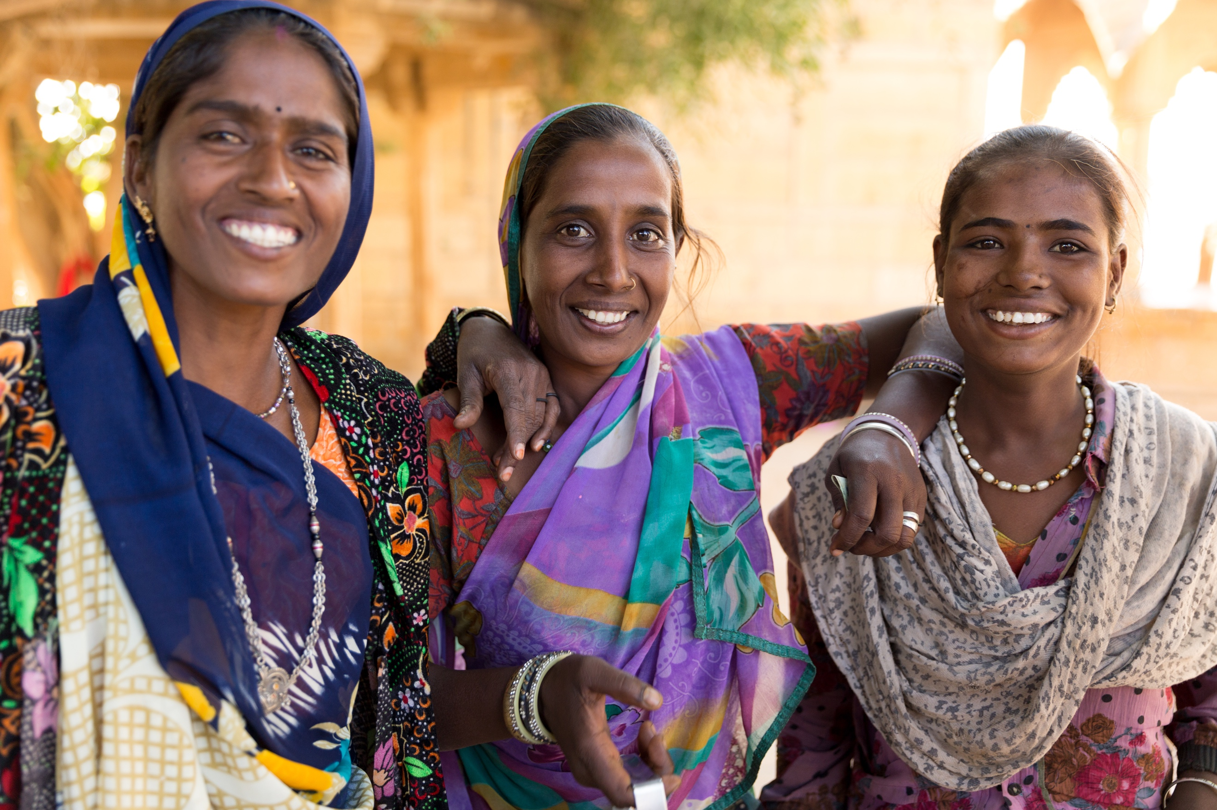

**In rural India, menstruation is a challenge for gender equality**

*By Alexandra D’Agostini*

For many of us, menstruation is a normal process that occurs every month. While we might suffer from minor annoyances such as pain and discomfort, it doesn’t usually have impact our personal and professional development. For many girls in the world, this is not the case. Menstruation prevents them from going to school or to work, and sometimes from performing daily activities like cooking, praying, exercising or even [being in their own homes](https://www.theguardian.com/global-development/2015/dec/22/india-menstruation-periods-gaokor-women-isolated). Widespread restrictions and negative perceptions around menstruation contribute to strong gender disparities in health, education and work participation. In India, which is ranked 125 out of 151 countries in the HDI [Gender Inequality Index,](http://hdr.undp.org/en/composite/GII) menstruation is still a barrier to achieving gender equality. This is true for urban slums but even more so for women in rural areas. The statistics are in fact quite alarming if we take into account that the average years of [schooling amongst girls is only 4.1 years versus 6.1 amongst their male counterparts.](http://www.thehindubusinessline.com/news/education/average-indian-spends-only-5-years-at-school-world-bank/article4778677.ece)

**Silence and Shame**

In rural India, menstruation is embedded in myths and taboos. Due to cultural and religious beliefs, menstruation is perceived as dirty, impure and even unholy. Because of this, menstruation is surrounded by a culture of silence and shame. Menstruating women are often expected to follow a set of restrictions during their periods, such as not going to the temple or offering prayers, not entering the kitchen and not touching certain foods.

Menstruation is not openly talked about in families or at school. It is actually estimated that over half of girls [don’t know about menstruation when they first get their periods.](http://www.ibtimes.co.in/half-indian-girls-dont-know-about-menstruation-until-they-get-their-first-period-study-680468) Their mothers are too ashamed to talk about it and frequently lack knowledge of the biological explanation of menstruation and of the adequate ways of managing periods. Schools tend not to fill this gap either. The issue is rarely discussed in classrooms and teachers themselves often find the topic embarrassing, perpetuating an environment of shame and secrecy around menstruation.

Furthermore, most rural women lack awareness or are too poor to buy sanitary napkins or tampons. In fact, it is estimated that [**only 12% of women in India use sanitary pads**](http://soothehealthcare.com/impact-of-unhygienic-sanitary-practices-on-womens-health/)**.** The most common alternative is cloth, and while cloth is not unhygienic *per se*, without proper care its use increases the risk of infection and other diseases. Misinformation and stigma often leads women to use unsanitary methods to manage their menstruations like dirty rags, leaves, sand or ash. Moreover, taboos prevent them from washing their cloth publicly and more importantly from drying it in the sun, so they frequently use damp cloth which is unhygienic and hazardous to health. It has been reported that reproductive tract Infections are [70% more common in women who don't use sanitary napkins](http://soothehealthcare.com/impact-of-unhygienic-sanitary-practices-on-womens-health/). Other diseases like urinary tract infections, fungal infections and cervical cancer have a higher incidence amongst these women as well.

**School Absenteeism and High Drop Out Rates**

Besides having important consequences on health, the inappropriate management of menstruation has a negative impact on the education of girls. It is estimated that around [20% of girls drop out of school after reaching puberty](http://www.thecitizen.in/index.php/NewsDetail/index/7/7836/Menstruation-Keeps-Girls-From-School-In-India-20-Drop-Out-Reaching-Puberty), and many more are absent for the entire duration of their period. While this might sound insignificant, missing around five days of school per month can affect their academic performance and can lead them to drop out because they are lagging behind at school. The main reasons for missing school during menstruation are a lack of adequate private toilets at school, and a lack of access to proper sanitary materials that are discreet and absorbent enough. The fact that menstruation is seen as shameful further encourages period-related absenteeism. Female teachers are also affected by these issues and will often skip work during their periods. Absenteeism and school dropout have an extremely significant impact in a woman's quality of life, making her more likely to get married early and have children while still in her teens, and affecting her economic independence and agency. Therefore, a gender gap in education and income will continue to exist unless serious efforts to fight these issues are undertaken.

**What Needs to Be Done**

Public policies and programs to ensure that all learning and working environments are gender-inclusive are urgently needed.  Building private and clean toilets in rural schools, ensuring the availability and accessibility of sanitary napkins and imposing mandatory menstrual health classes for both boys and girls are important measures that can potentially keep many girls from being absent or dropping out of school.

Furthermore, all women should be granted access to quality sanitary pads, tampons or other hygienic methods of protection. According to the WSSC, sanitary pads have the potential to improve girl’s attendance to school, since they prevent issues like staining and odor. They also significantly decrease the chances of infection and gynecological disease. Self-help groups, NGOs and other actors are starting to produce low-cost pads for rural women, but many women in remote areas are yet to be reached. When combined with WASH (Water, Sanitation and Hygiene) and MHM (Menstrual Health Management) awareness campaigns, these initiatives can have a long-lasting impact on the health of women.

And even though sanitary napkins are recognized by most urban women as essential, they are still considered an unnecessary luxury for many. In fact, the government of India recently decided to impose a [12% luxury tax](http://indianexpress.com/article/opinion/columns/taxing-gst-sanitary-pads-tax-regime-women/) on sanitary napkins. In a country in which most women cannot afford such a basic product, the controversial measure was received with a lot of opposition. A campaign named #Taxfreewings was launched alongside a petition to remove the tax on sanitary napkins. You can read and sign this petition [here](https://www.change.org/p/arunjaitley-taxfreewings-petition-for-removal-of-tax-on-sanitary-napkins).

 Fortunately, menstruation is being talked about more openly in the public domain, and menstrual hygiene is slowly emerging as a human rights issue, but a lot of progress still has to be achieved. Ultimately, the goal is that every girl in every corner of the world has access to proper sanitation during their periods, and is aware that menstruation is a normal bodily function and that nobody has the right to shame her for that.