[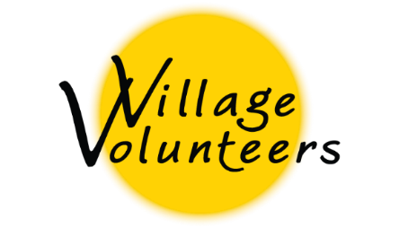](http://www.villagevolunteers.org/)

**Volunteer Post-Program Survey**

To assist us in improving the experience of future volunteers, we would be grateful if you could share your insights and advice. Thank you for your honest feedback.

1. Is there anything you encountered during your trip that you feel you were not prepared for?
2. Do you have any advice for future volunteers?
3. Did you feel safe and cared for while in the village(s) you visited?
4. Did you feel safe and cared for while traveling between villages (if applicable)?
5. Did you feel that the new volunteer orientation that you received upon arrival at your program was adequate?
6. What types of activities did you participate in while in the village(s) you visited?
7. Would you recommend these activities for future volunteers?
8. Do you feel like your expectations were met, and that you had the guidance and support needed to feel at ease with your tasks?
9. How was your communication and relationship with each village contact? Did you feel comfortable voicing concerns or issues you might have had?
10. Did you feel the accommodations, meals, and water were adequate?
11. Did you feel adequately prepared for your volunteer experience?
12. Is there anything else you’d like to tell us or any advice on how to better the Village Volunteers experience for future participants?